**INDIAN INSTITUTE OF INFORMATION TECHNOLOGY,NAGPUR**

**Name:** Khirade Gaurav Ramesh

**Roll no.:** BT20ECE089

**Branch:** ECE

**Semester: 6th**

**Instructor: Dr. Paritosh Peshwe**

**CMOS DESIGN**

**PROJECT REPORT**

**Seven segment hex decoder**

**INDEX**

|  |  |  |
| --- | --- | --- |
| **S. No.** |  | **DESCRIPTION** |
| **1** | **Abstract** |  |
| **2** | **Introduction** |  |
| **3** | **Circuit Diagram** |  |
| **4** | **Simulation Layout** |  |
| **5** | **Simulation Program** |  |
| **6** | **Results** |  |
| **7** | **Conclusions** |  |

**Abstract:**

7-segment HEX decoder circuit will turn on and off the segment for displaying a particular information. Here in this table ‘1’means positive voltage and ‘0’ means 0 volt. We are using a common cathode 7-segment display so ‘1’ means a particular segment is on and ‘0’ means a particular segment is off.

**Introduction:**

A seven-segment, like the one shown in Figure is a common output device used in many digital applications like timers. The seven-segment is so called because of the seven LEDs, or segments, it is composed of. There are two types of seven segment displays, common anode and a common cathode seven-segment display. In either case, one end, either positive or

negative, of all the seven segments are connected together to a common pin. The seven-segment in which positive end of all the segments are joined together to a common terminal is referred as a common anode seven segment. On the contrary, common-cathode seven-segment display has negative terminals of its seven-segments connected to a common node. To light a segment in the seven-segment display, the common terminal is first connected to logic high for common anode or to logic low for common cathode. The other ends for individual segments are then connected to logic low for common anode and logic high for a common cathode type seven-segment display.

A seven-segment display (SSD) is an electronic display device for displaying numbers from (0 – 9). Additionally, 7-segment LED to allow the display of letters (A – F) and some alphanumerical 7-segment decoders consist of 7 rectangular LEDs (segments) arranged together in shape of “8”. In order to produce the required number or character, a specific combination of LED segments needs to be illuminated.

SSD takes generally a 5 V DC power supply and has 7 digital pins named after the first 7 letters of the alphabet (A to G). The segments are lit on by applying an ‘LOW’ logic level to the cathode. As this device is made out of LEDs, it requires resistors order to limit the current supply.

**Seven segment display:**

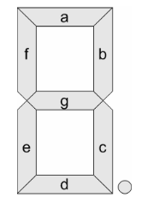

**Circuit diagram:**

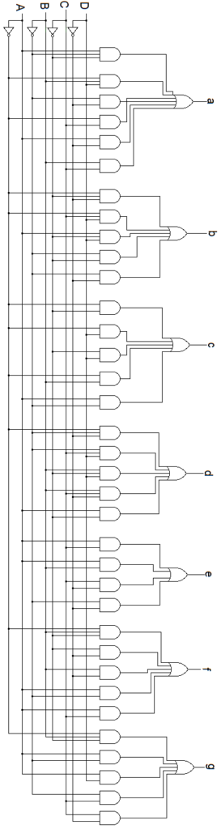

**1.     For segment ‘a**

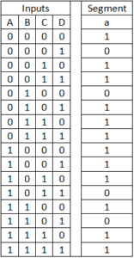

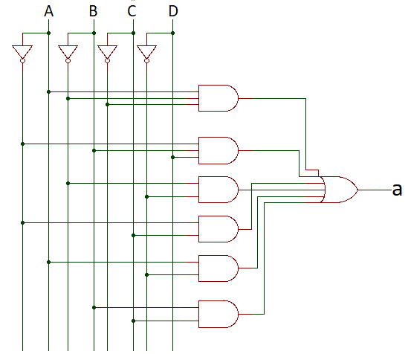

### 2.     For segment ‘b’

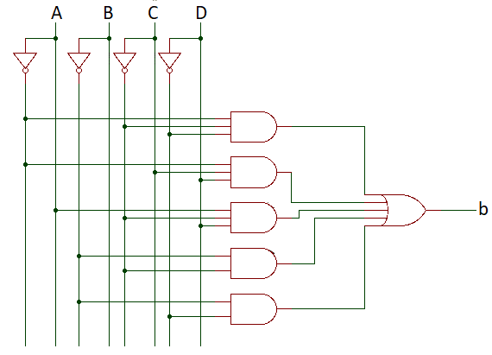

### 3.     For segment ‘c’

Logic diagram –

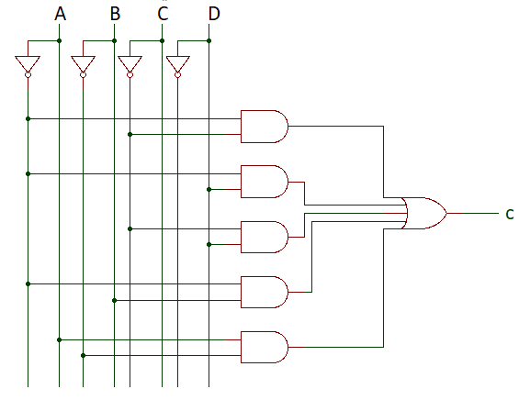

### 4.     For segment ‘d’

Logic diagram –

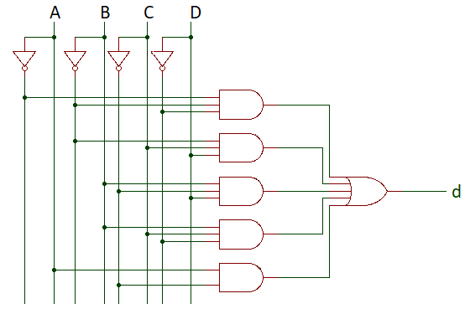

**5.     For segment ‘e’**

Logic diagram –

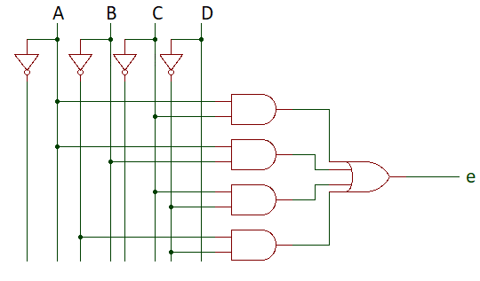

**6.     For segment ‘f’**

Logic diagram –

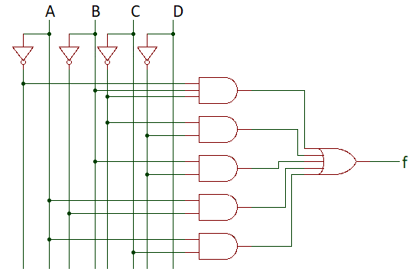

**7.     For segment ‘g’**

Logic diagram –

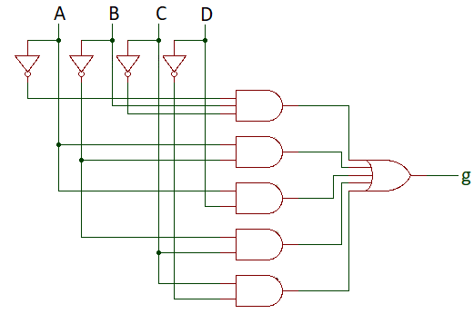

**Simulation Layout:**

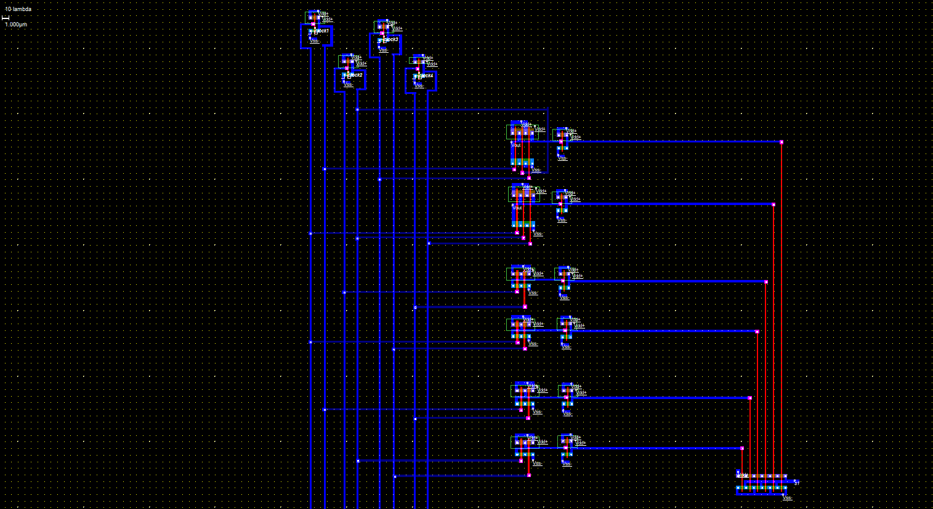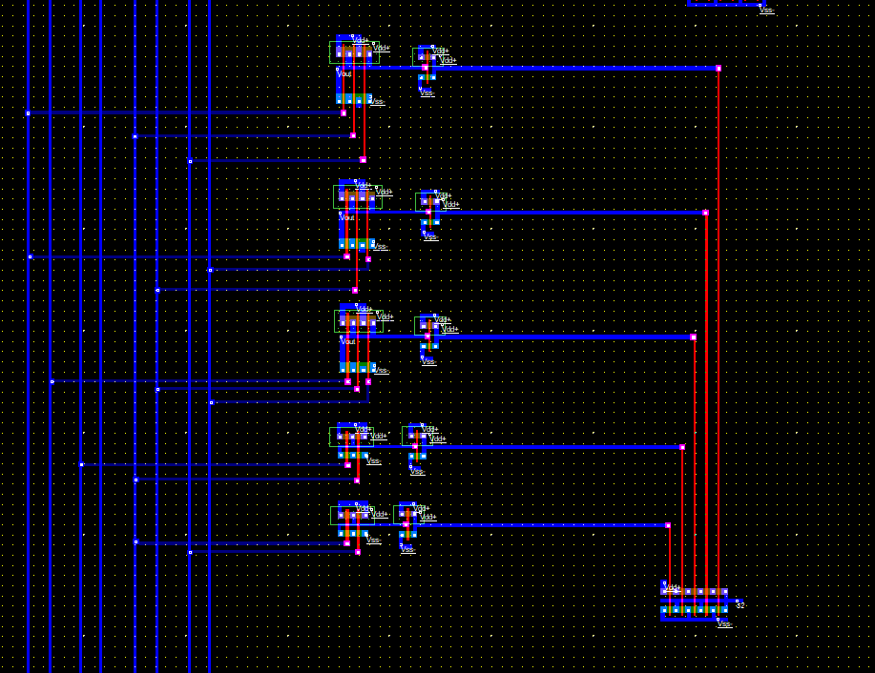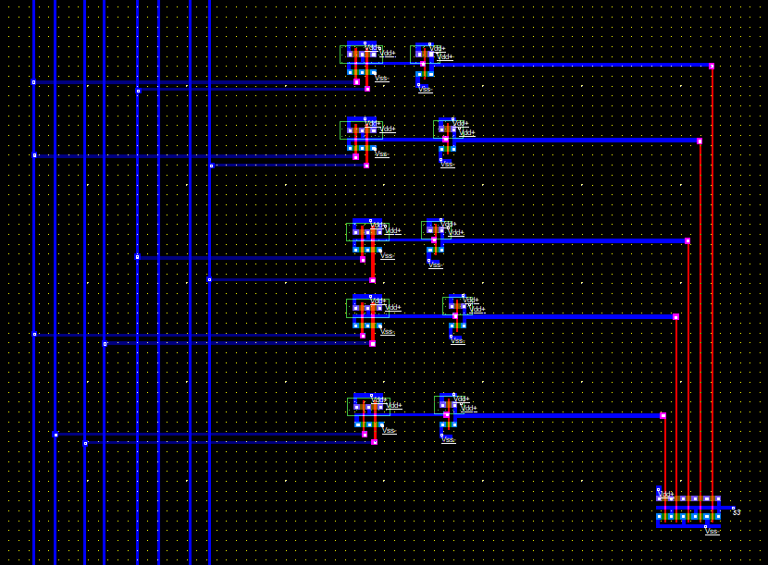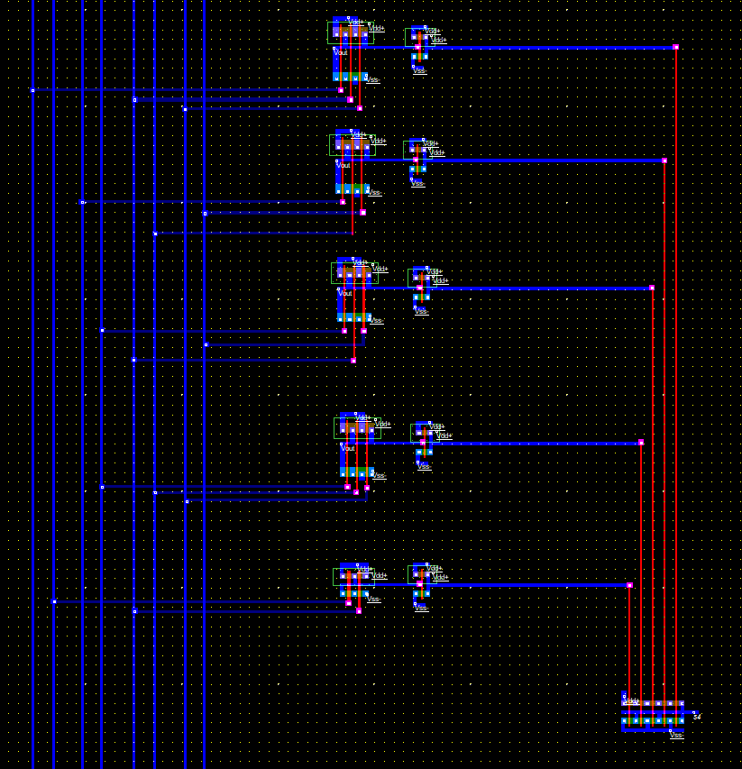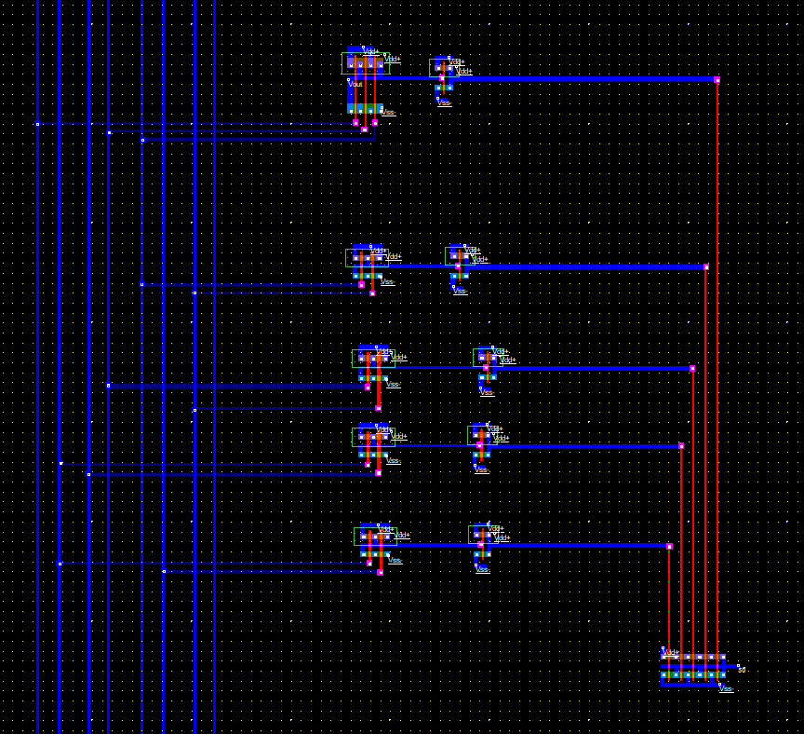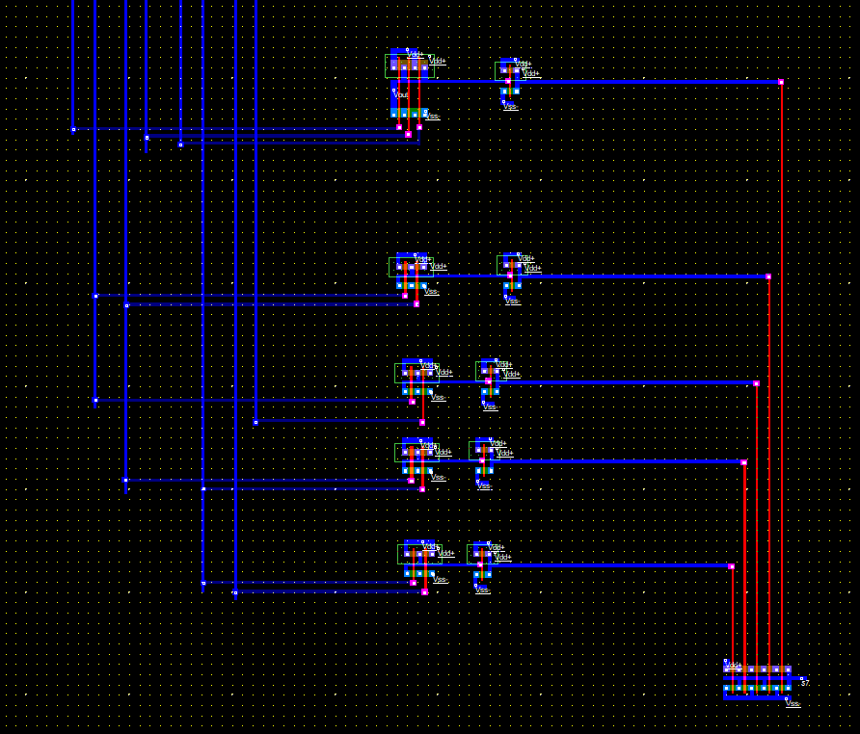

**Output:**

Output for inputs A B C D and output S1, S2, S3, S4, S5, S6, S7

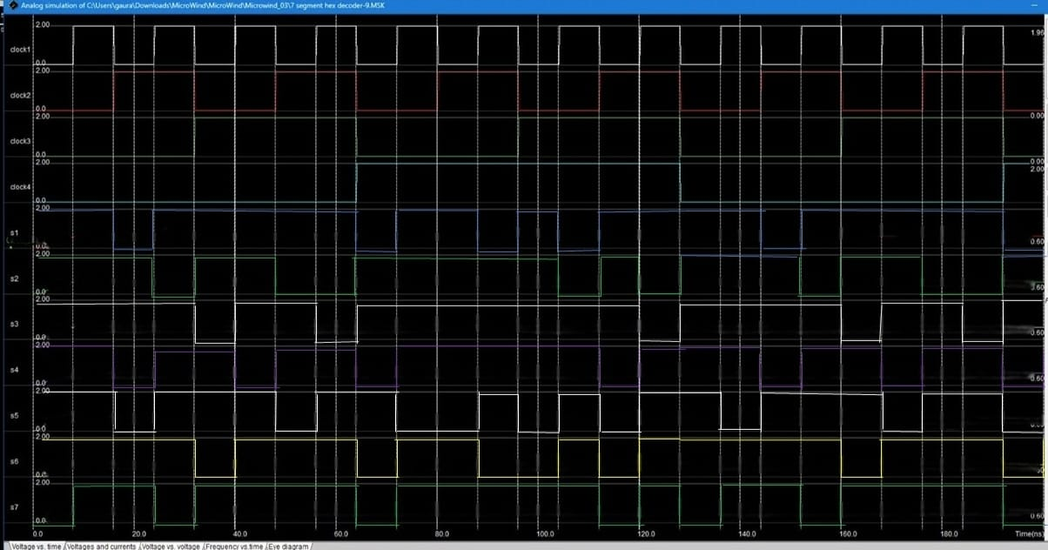

**Results and Conclusion:**

The seven-segment decoder, which has four input lines and seven output lines (a, b, c, d, e, f, and g), receives this BCD (A, B, C, and D) input. The output is provided to a seven-segment LED display that shows the decimal number depending on the inputs.

* It is possible to display any single digit number on a 7-segment display by sending a high digital signal to the specific segments that make up the number. However, this method requires us to encode the letters manually. It is not the best solution to output changing numbers for application such as counters.
* It is possible to display the decimal value of a binary number on a 7-segment display using a BCD decoder.
* However, this method will allow displaying only digits from 0 to 9 and letters A to F.
* The only way to display number more than 9 is to use a display that has more than 7 segments or just using multiple 7-segment displays at once with the corresponding BCD decoder.

* In the case of the decoder circuit, any binary number between 1010 through 1111 (A to F) is an invalid input and would provide distorted shapes on the LCD display.
* Current limiting resistors of 150 ohms are connected in series between the decoder and each of the LED display segment. They serve to limit the maximum current flow and have no impact on the LCD display.
* The usage of a 7-segment display paired with a BCD decoder is opening the door for an application using digital computation requiring a human-readable That application can be for instance: “a clock, a timer, a calculator, counter…”